Commercial Chassis Operator Manual Search Guide
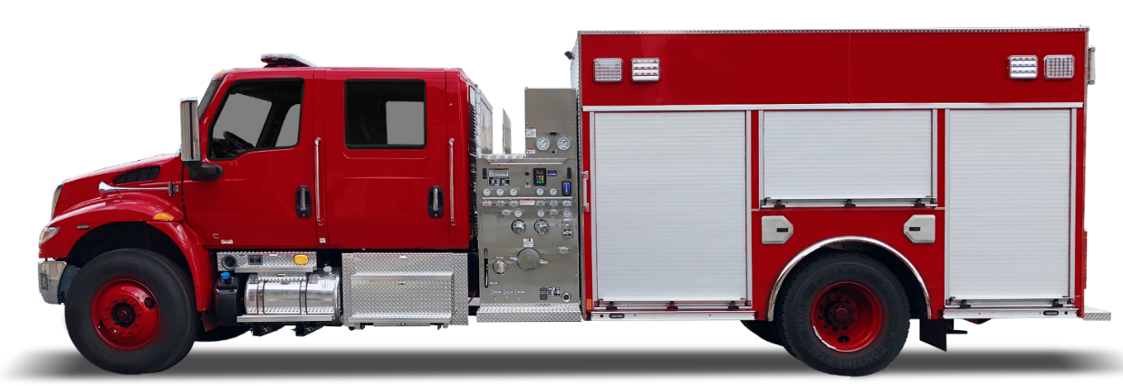

Commercial Chassis Operator Manual Search Guide
Owners or operator manuals for your commercial chassis can be found on the internet. This guide is intended to help you find your commercial chassis manual so you can become familiar with the safe and proper operation before you drive or operate your commercial-chassis equipped fire apparatus.
The instructions were accurate at the time of publication, but websites are subject to change. If these instructions do not work, call up the manufacturer’s main website and follow the selections to find your manual.

Contents
Freightliner 3
International 4
Kenworth 6
Peterbilt 7
Ford 8

Freightliner
Operator manuals for Freightliner chassis can be found at the following link:
https://www.dtnatechlit.com/portal-public?make=freightliner
Check the box next to the chassis model and click on SEARCH.
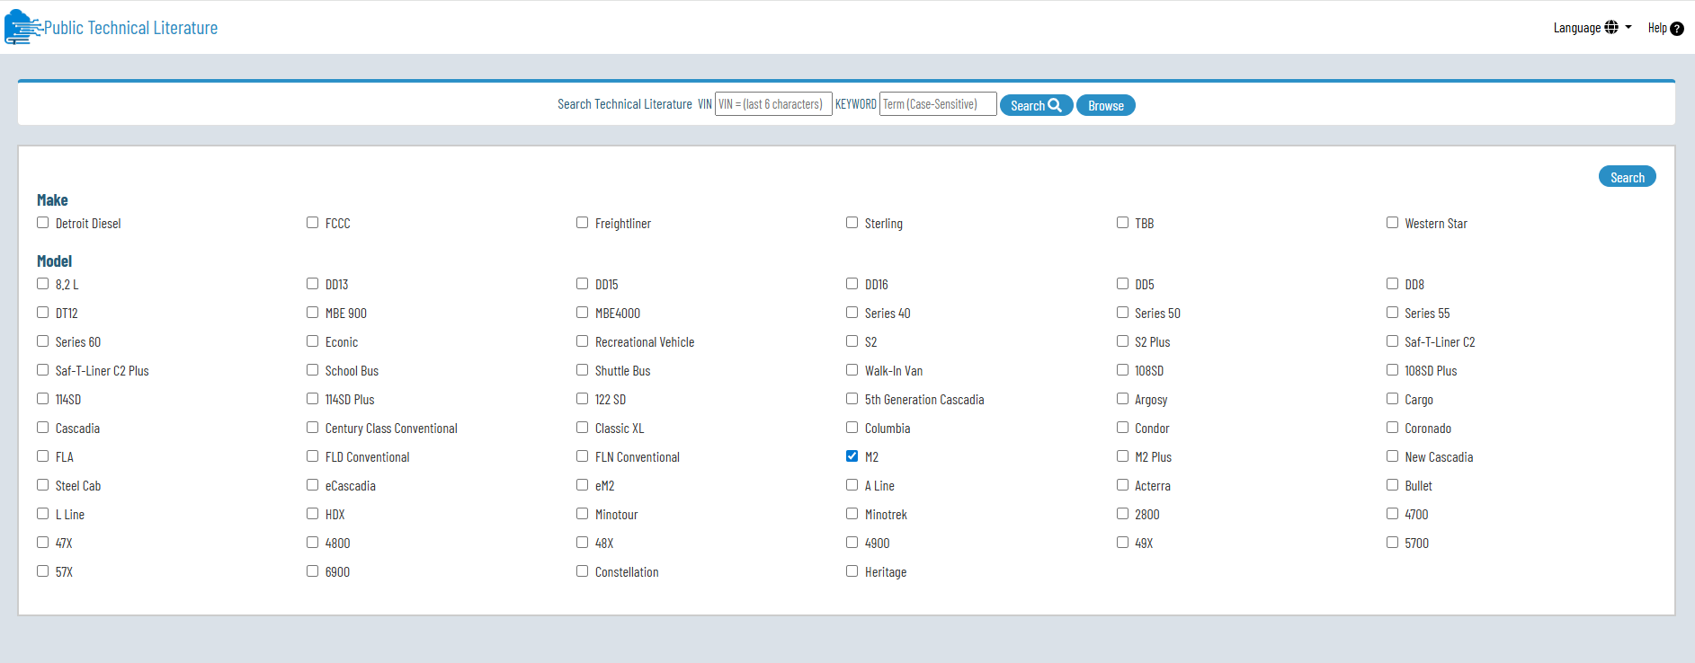
Chassis operation instructions can be navigated to using the outline on the left of the screen. Below is an example for “Entering from the Driver’s Side”
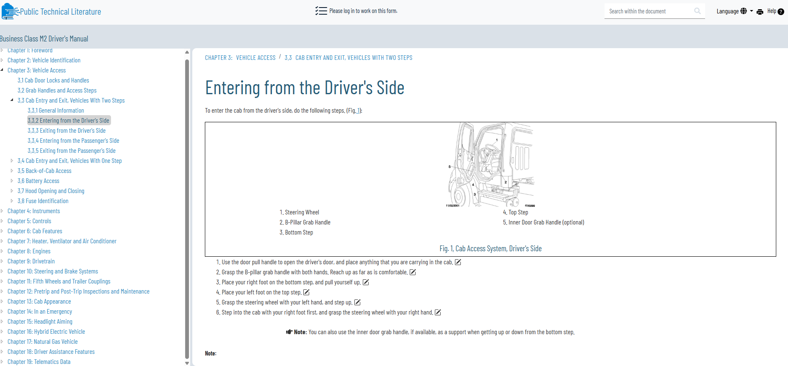

International
Operator manuals for International chassis can be found at the following link:
https://www.international.com/products/resources

Scroll down to the Product Manuals section and click on EXPLORE

Select which method of delivery you prefer
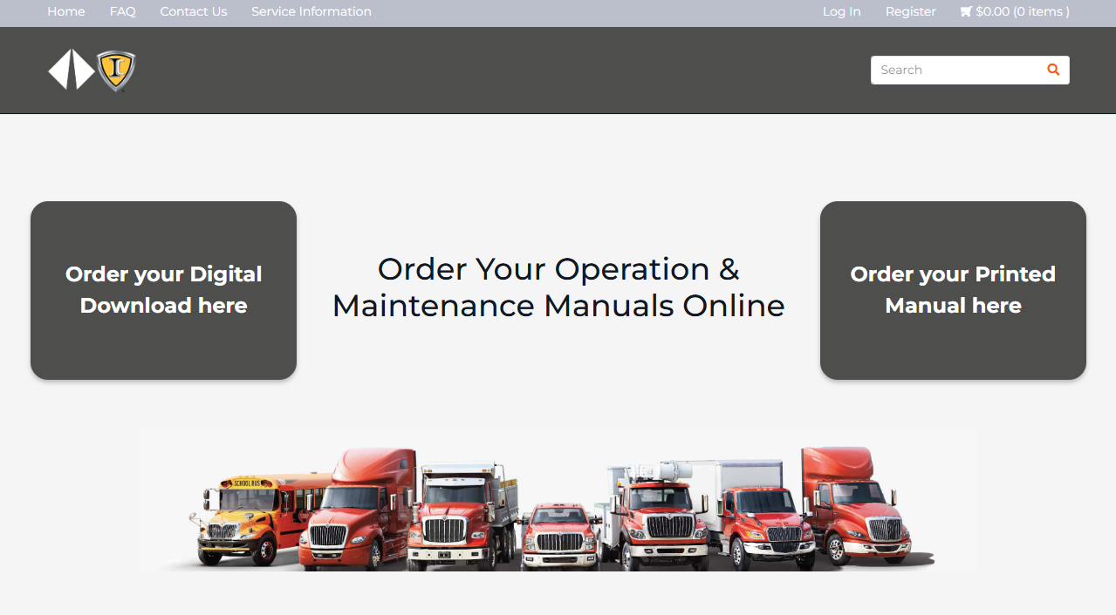
Choose your language
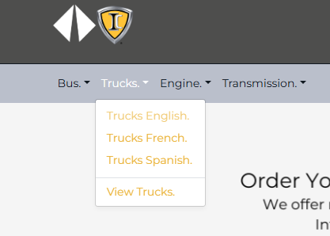
Select the Model chassis
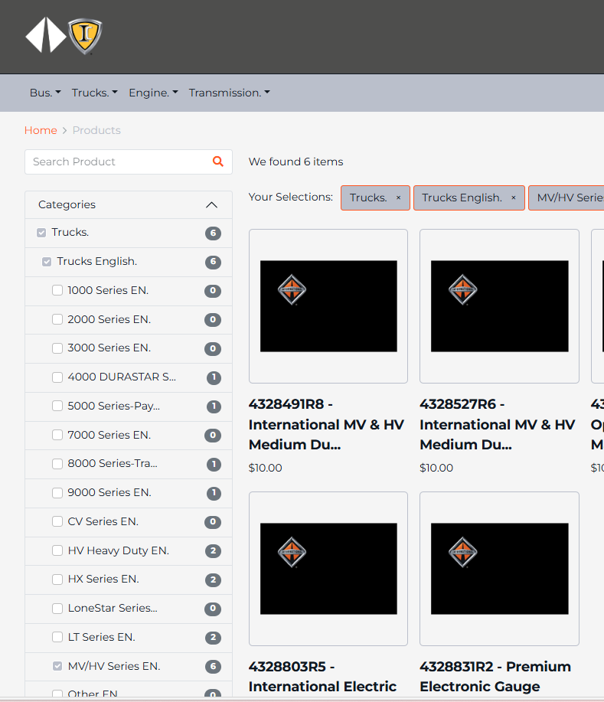
Select the appropriate manual based on the model and model year
Complete the registration and purchase methods.

Kenworth
Operator manuals for Kenworth chassis can be found at the following link:
https://www.kenworth.com/resources/manuals/
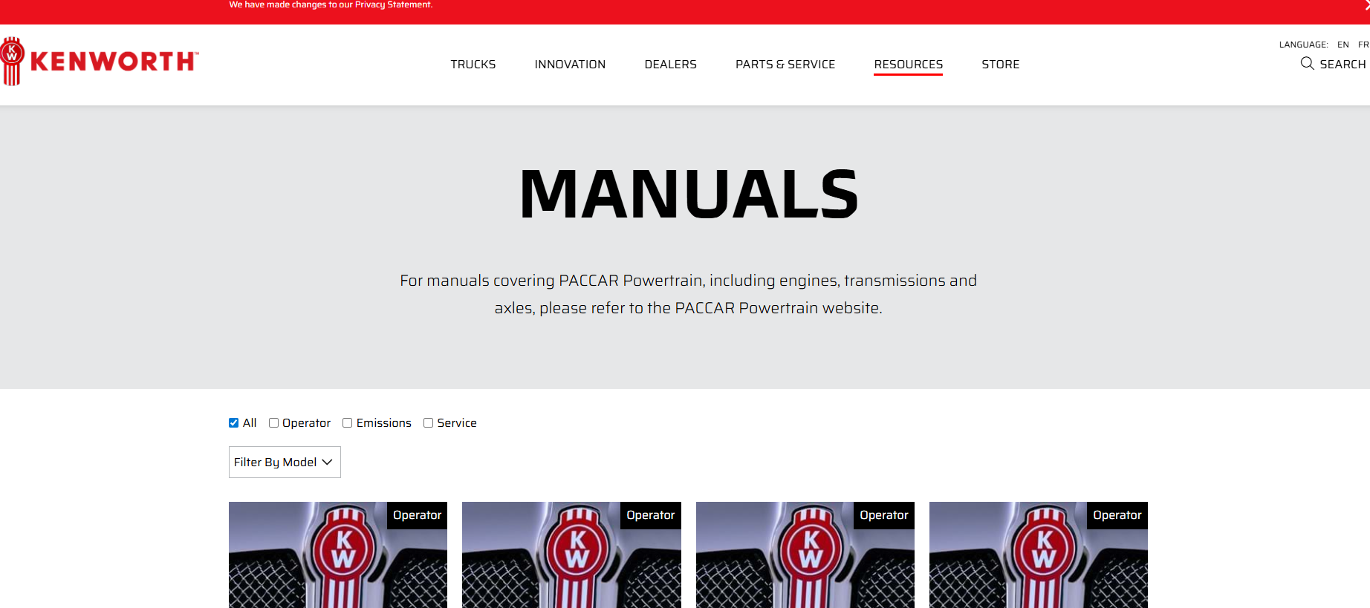
Scroll to and click on the icon for the correct model and language
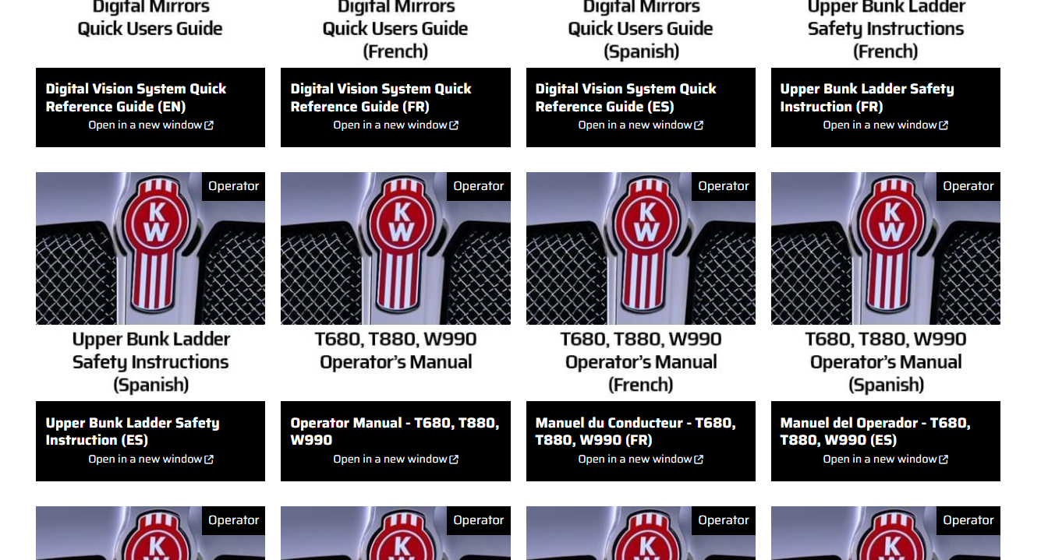
Read or download the manual (example shown)
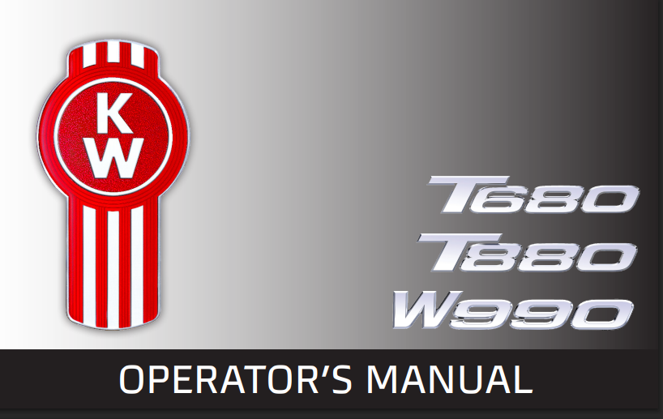

Peterbilt
Operator manuals for Kenworth chassis can be found at the following link:
https://www.peterbilt.com/resources/
Scroll to and click on the icon for the correct model and language
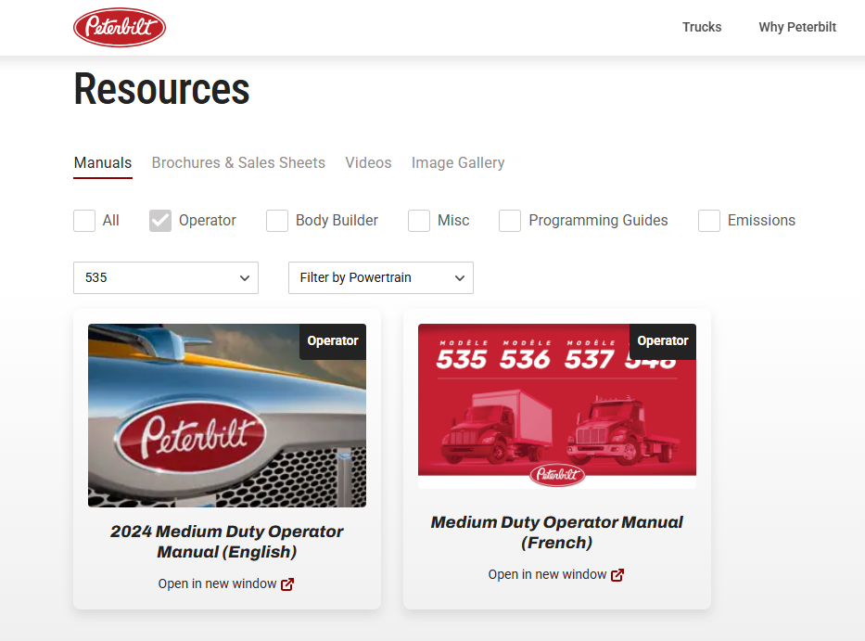
Read or download the manual (example shown)
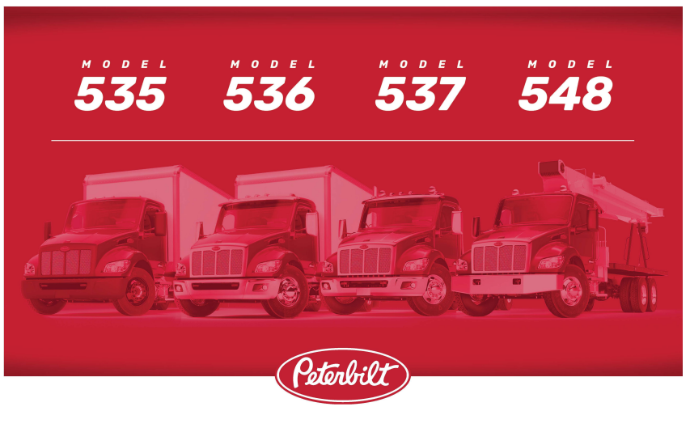

Ford
Operator manuals for Ford chassis can be found at the following link:
https://www.ford.com/support/owner-manuals-details/
Enter the Year and Model, or enter a VIN
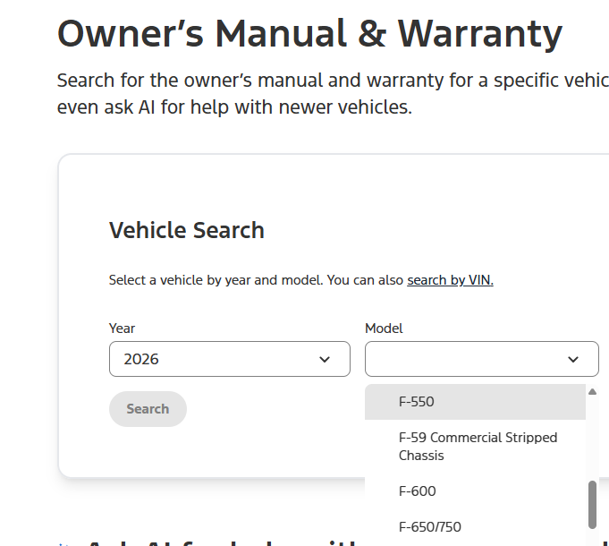
Select whether you want the original manual in PDF, or use the on-line manual.
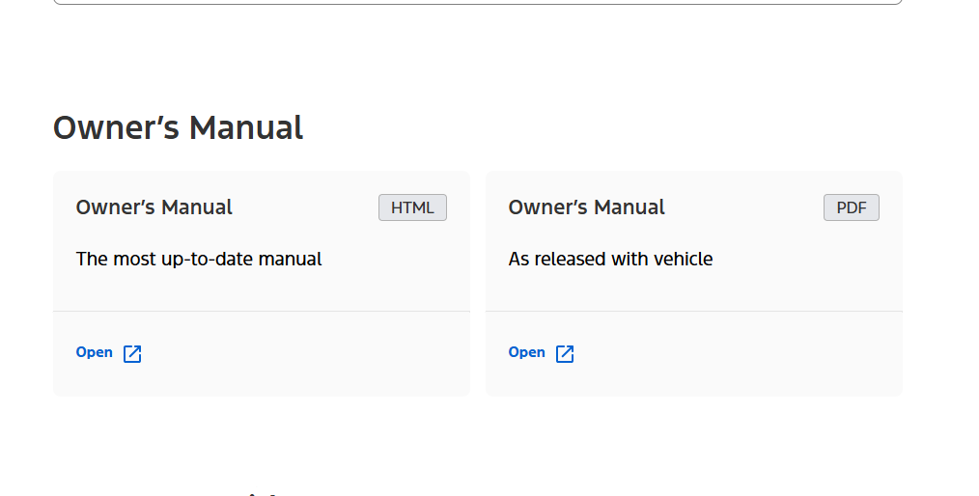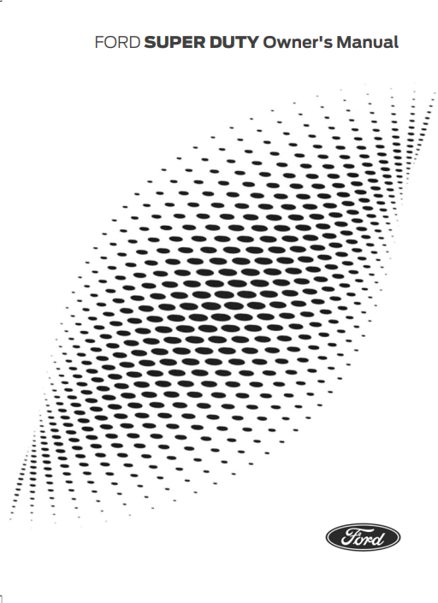
Read or download the manual (example shown)

